Curriculum Vitae | Bogdan HORVAT
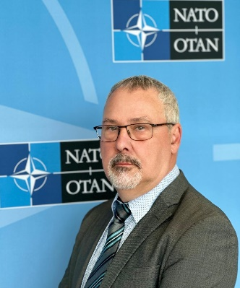
 | +32 471 786 228
 | consultd2b@gmail.com

Mr Bogdan Horvat graduated from the Military Academy in 1985 in Belgrade, Serbia, with a thesis on an engineering unit providing temporary means for a brigade advance during a large-scale military combat operation.

For over 25 years of his professional career, he held a number of command and staff positions in the Slovenian Army (SA) and senior positions in the Ministry of Defence of the Republic of Slovenia. The most important military assignment was a company commander in the first generation of Slovenian soldiers, playing an essential role in the first years of the creation of the Slovenian Army. That led him to different staff positions in the Slovenian Army before he started his career in the Ministry of Defence. In February 2002, his NATO career began in the Defence Support Division/Land Section as a Voluntary National Contribution from the Slovenian Ministry of Defence. A year later, he moved to the Slovenian Delegation to NATO in the position of Defence Adviser for Armaments (Deputy NADREP and NADREP). During almost seven years in that position, he worked on countless armaments-related issues, being involved in the work of Main Armaments Groups (MAGs), NATO Industrial Advisory Group (NIAG), Life Cycle Management (LCM) and Ammunition Safety. In addition to that, he actively participated in several essential NATO projects, such as Alliance Ground Surveillance (AGS), Active Layered Theatre Ballistic Missile Defence (ALTBMD), Missile Defence (MD), Strategic Airlift Capability (SAC) and Defence Against Terrorism (DAT). SAC was the most rewarding project he was involved in, having the great privilege of being the very first Strategic Airlift Management Organization (NAMO) Board of Directors (BoD) Chairperson. He was also a member of NAMSO BoD, significantly contributing to Slovenia becoming a NAMSO member shortly after its NATO accession.

After leaving Slovenian MoD, he took over the position of Executive Officer in the NATO Alliance Ground Surveillance Management Agency (NAGSMA), which he held for 14 years. As such, he was responsible for providing agency executive support and ensuring the dissemination and realisation of executive decisions. In addition, he was responsible for coordinating the executive staff functions, steering processes and promoting and maintaining professional relationships with senior members of International Staff (IS), International Military Staff (IMS), NATO Support and Procurement Agency (NSPA), NATO Communication and Information Agency (NCIA) and commercial entities related to the AGS Programme activities. Being responsible for Public Relations, he was the first point of contact representing NAGSMA at external meetings, conferences, and symposia.

During my 22-year-long career in NATO, he met countless people and built an impressive network of NATO and national professionals.

His knowledge and experience in NATO processes are unprecedented and unique. He certainly is the right person for everyone who wishes to develop or enhance cooperation with NATO.

Mr Horvat left NATO in December 2023. In January 2024, he founded D2B Consult SIA, a consultancy company that provides unprecedented-quality advice to individuals and companies interested in working with NATO and national authorities. He joined ASSIG in January 2024 as an associate consultant.

Together with his family, he enjoys outdoor activities, especially golf as well as travelling.

